Quotation:
HN-6025GA FIBER LASERMACHINE

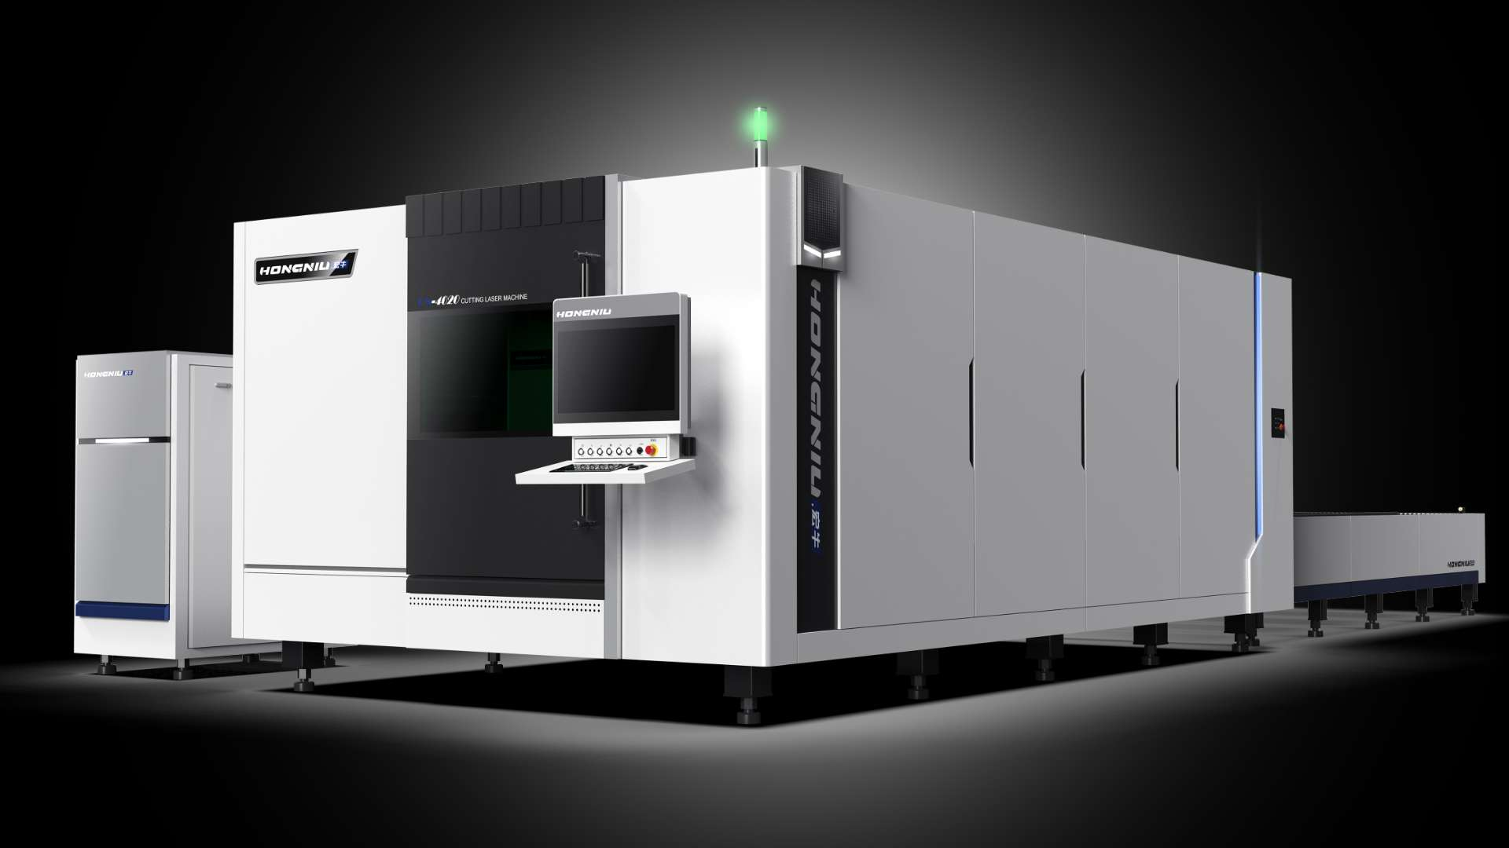
model | Standard Equipment |  |  | Power |  |  | Fiber Source | FOB Qingdao Price
HN-6025GA | 1.6000*2500mm working surface exchange table with cover  - Raycus fiber laser source CE with globe service  - BOCI BLT642H laser head  - Cypcut 8000C control system  - Control cabinet independent  - Air condition for cabinet of machine  - Japan Yaskawa servo motor and driver Z: 750W, X: 2.9KW Y axis 4.4kw  8.22kwn16barn  Other standard equipment  ( such as: servo-motor,bearing etc.) |  |  | 12kw |  |  | Raycus | 85000$/set
 | Payment Terms |  | 30% in advance; 70% before delivery.
Payment | Price Validity |  | 20 days
 | Lead Time |  | 25 working days
Shipping | Shipping cost to Mersin Turkey |  | 00usd/container
Shipping | Packing suggested |  | 40HQ*1
 | Shipping Time |  | 45 days arrive.

Total amount CIF to Izmir Turkey : $
Engineer Overseas Training Cost
1. | Technician visa fee: $ RMB ($)
2. | Training and maintain commission: $150/day/person( 5 to10 days)
3. | International round-trip tickets: around $
4. | Abroad accommodation
Spare Parts for one Years’ Using
Items | Unite price |  | Suggested | lifetime |  |  |  | Amount
Nozzle | $15 |  | 10*pieces |  |  | 1 month |  |  | $150
Protection lens | $20 |  | 5*pieces |  |  | 1 year |  |  | $100
Focus lens | $180 |  | 1*piece |  |  | 1 year |  |  | $180
Collimating lens | $180 |  | 1*piece |  |  | 1 year |  |  | $180
Ceramic ring | $50 |  | 1*piece |  |  | 1 year |  |  | $50
Remark: The quotation on page one include one set of spare parts and has been installed in laser head, besides, 9*nozzle and 4*protection lens are also included already in the quotation as replacement parts.

- WARRANTY: machine 5years
- Leading time:in 25 working days

- METHOD OF PAYMENT:T/T

- TRADE TERMS:CIF

- PAYMENT REQUEST: Deposit 30% down on the contract price,70% payment before shipment

- QUOTATION VALIDITY: in 20 working days
- GUARANTEE:

(1)24 hours online service
(2)User-friendly English manual and Video CD for machine using and maintaining.
(3)overseas support

- machine details

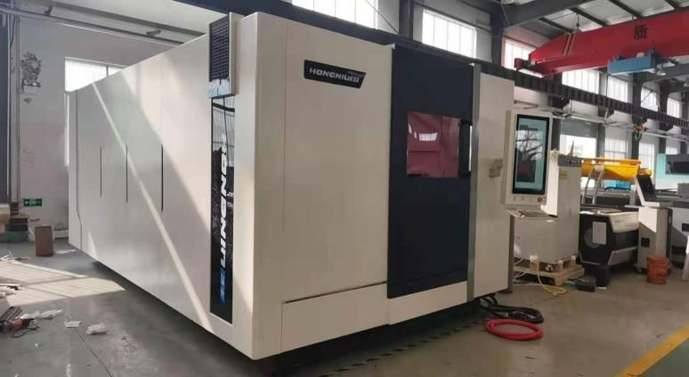 | 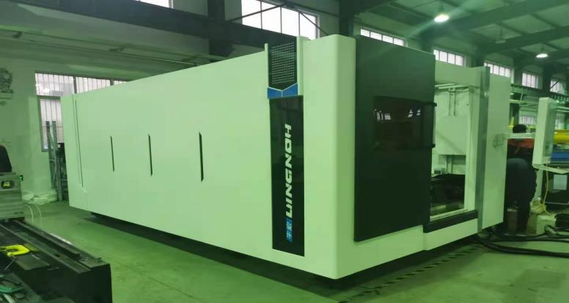
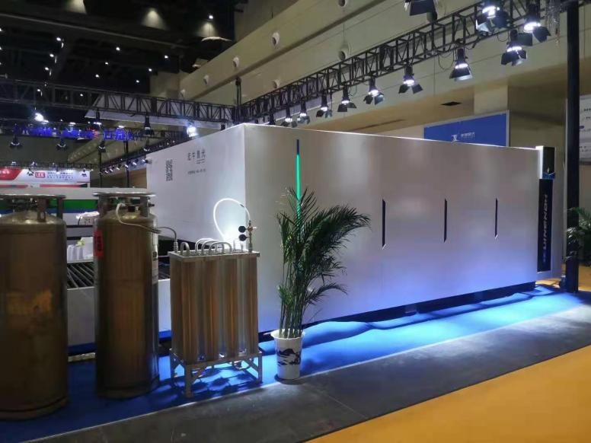 | 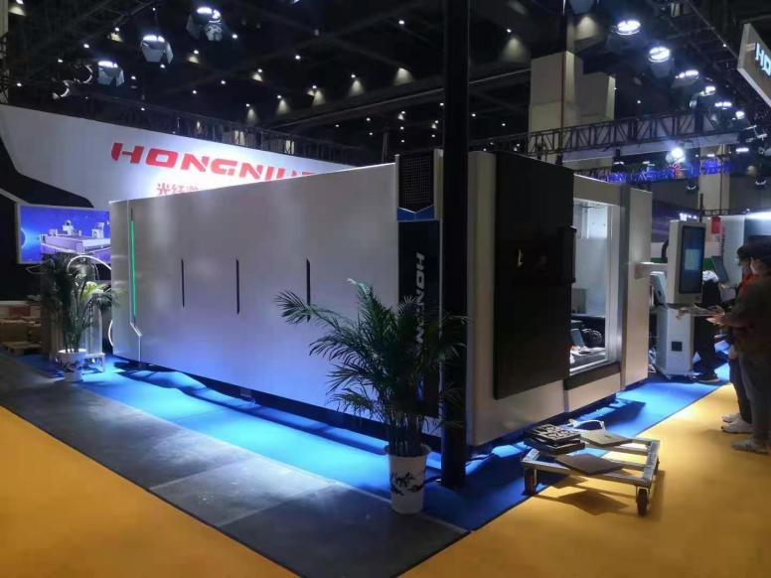

The global exhibition
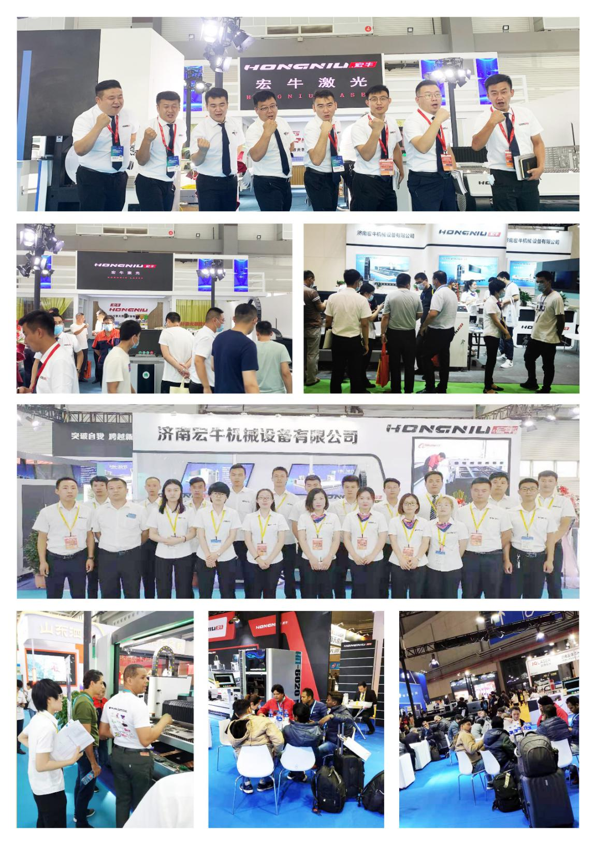
Ⅴ Machine Instruction
5.1 Introduction of HN-6025GA single table machine
Hongniu fiber laser cutting machine is a mature product that has reached the domestic advanced level. This series of products is recommended for the metal material processing industry. The bed is a honeycomb carbon structure, which has undergone aging annealing treatment. , The running speed of the machine is extremely fast, and the processing efficiency is greatly improved.

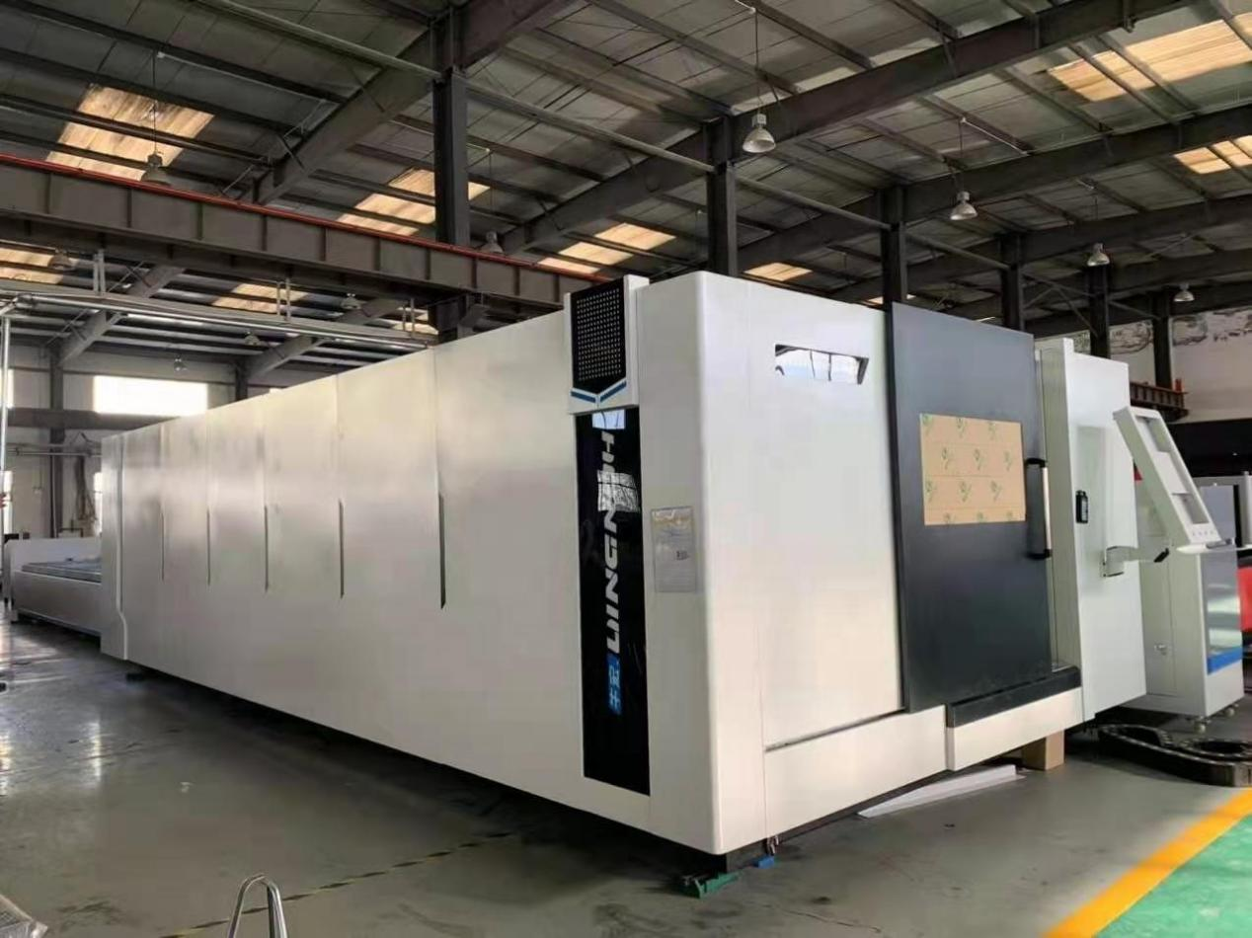
The cutting head has an automatic tracking system， adopts capacitive induction control, which makes cutting head kept same distance from workpiece surface, so that the distance between the nozzle and the surface of the workpiece that can finish not only flat metal sheet cutting but also some concave&convex surface metal sheet cutting.
Fine cutting quality: non-contact cutting, edge cutting gets less affected by heat, nearly no thermal deformation of the workpiece, slump formed can be avoided , almost linear cutting can be finished by one time and no need repaet work。
Save mold investment: It can complete the processing of various complex structures by drawing any image on the computer for laser processing, no mold, no mold consumption, no need to repair the mold, save the time to replace the mold, which save the processing cost , reducing the production cost, especially suitable for the processing of large products.
Material saving: Adopting computer programming, which can nest different shapes of workpiece, improving material utilization.

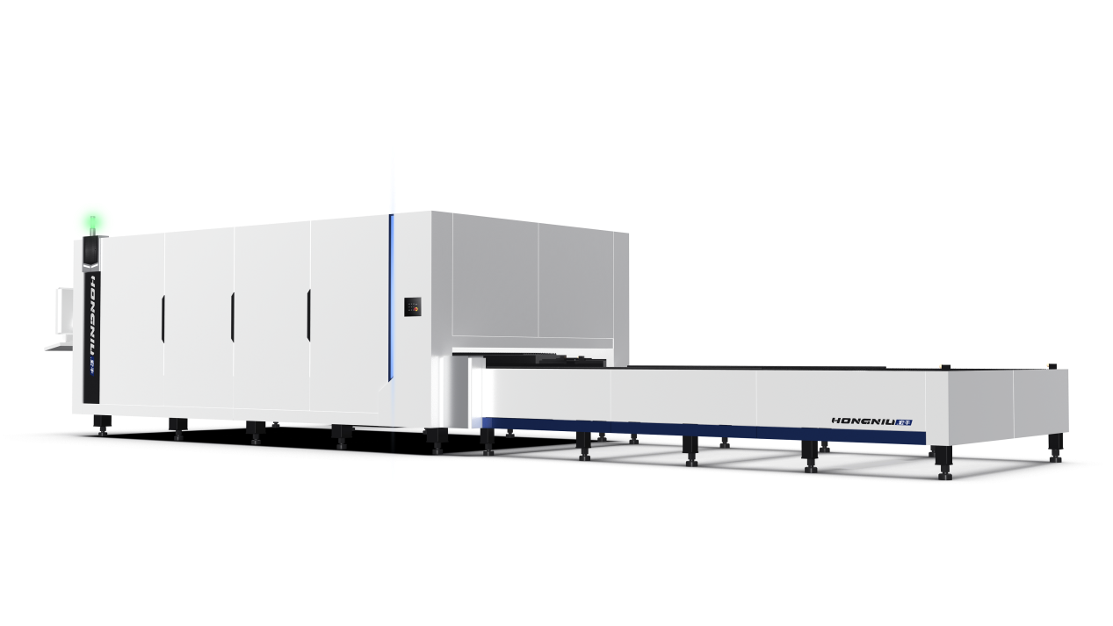

5.2 Features
5.2.1 Machine Frame  Adopt high-strength steel structure or aluminum alloy beam, light weight and good dynamic performance, rough machining after annealing to eliminate internal stress, and finishing after secondary vibration aging treatment to ensure the overall strength stability of the beam. | 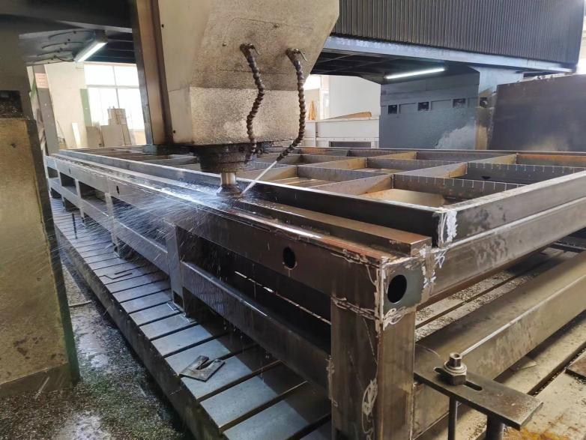
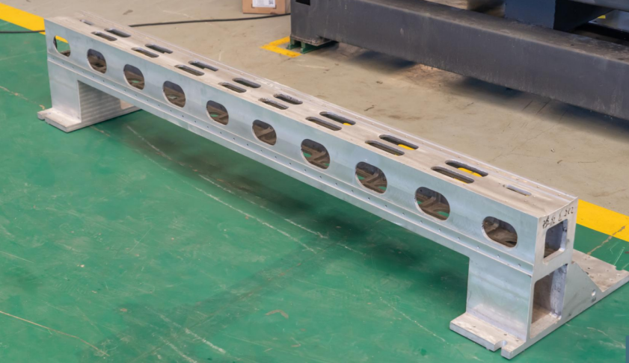 | 5.2.2 Gantry Beam  Adopting high-strength steel structure or aluminum alloy beam, lighter weight, better dynamic performance, rRough machining to relieve internal stress after annealing, finishing after secondary vibration aging treatment, which guarantee stability of whole gantry beam.
5.2.3 Multi-function CNC Control System  Cypcut control system, which has features such as intelligent diagnosis, multi-thread operation, three-level perforation, controlling laser energy , finding adaptive edge , corner acceleration and deceleration automatically, flying cutting, mechanical precision compensation, etc | 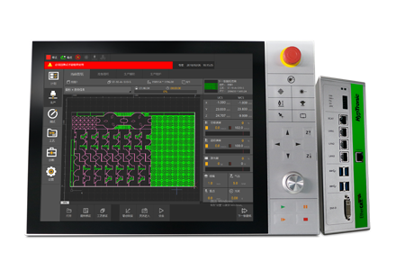
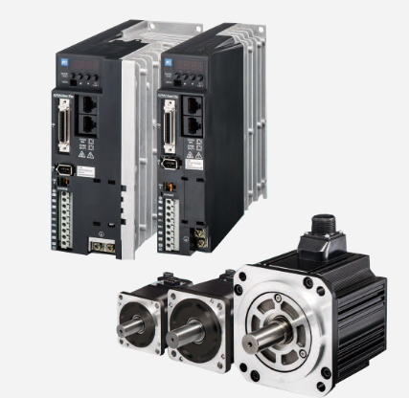 | 5.2.4 Servo motor and Driver  High-performance servo motor adopts a one-step locking connector, which is highly resistant to vibration and shock. The debugging is convenient, operation is more stable, the positioning faster, which can match servo drive to control the position , speed and torque .
5.2.5 Laser Source(Raycus Laser Source)  Raycus fiber laser source supplier has R&D, producing, serving , to vertical integration capability from materials , parts, to whole laser source having global influence | 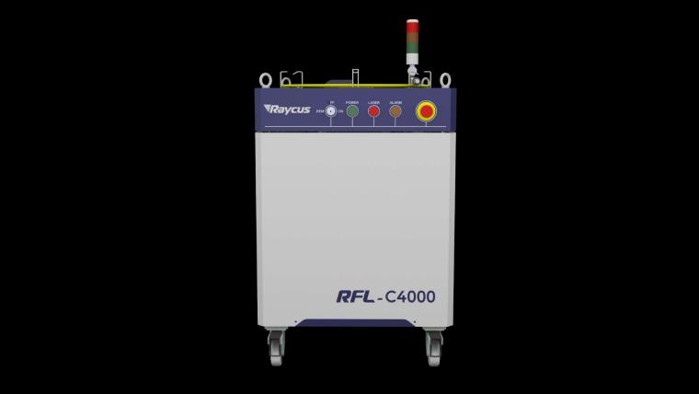
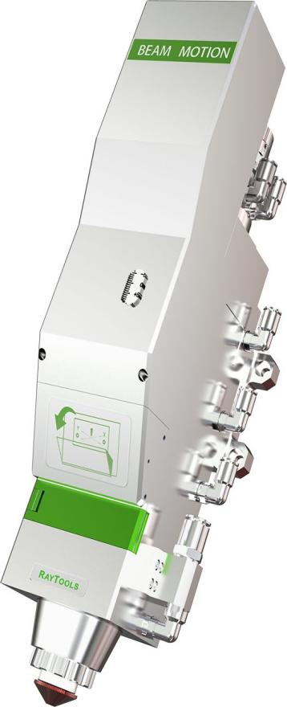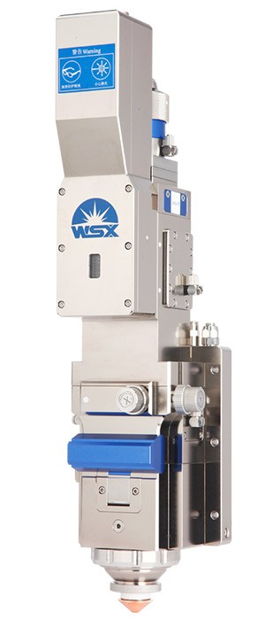 | 5.2.6 Laser Head  1. The cutting laser head has great advantages in medium power large platform cutting applications  2 laser head is completely sealed which avoiding optical parts polluted by dust  3. The laser head adopts two-point centering adjustment, focusing adopting imported motor drive, which improves the punching efficiency
HM22-16 Skid mounted screw air compressor | 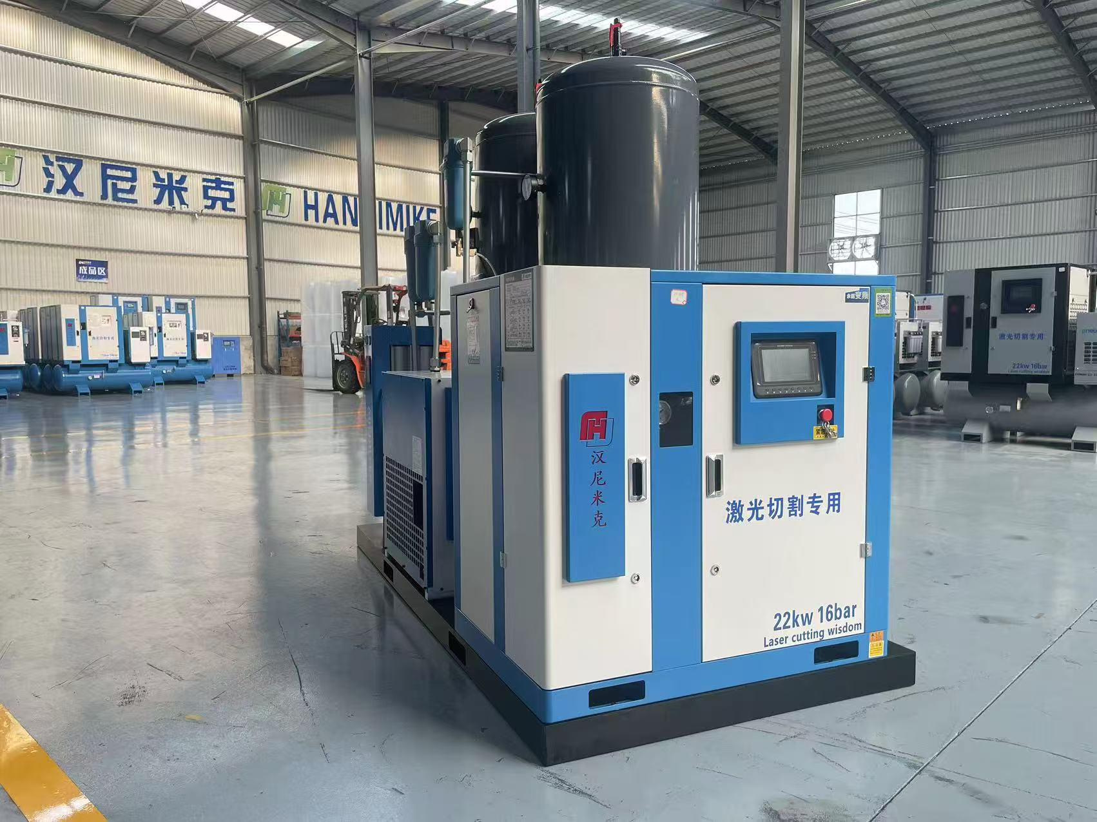
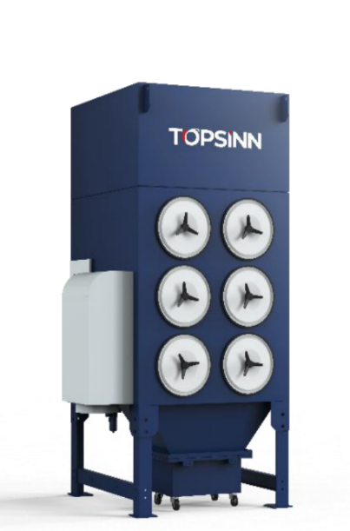 | TODC-8B/11KW
Technology Parameter
7.1 Configuration Parameter
Item | Model | Name | Unit | Remark
1 | HN-6025GA double table with cover | Fiber laser cutting machine | 1set | Effective working area：6000mm*2500mm  Cutting precision :（±0.02mm）
2 | 12kw | Laser power source | 1 set | Brand: Raycus
3 | Laser cutting head | High precision professional laser cutting head | 1 set | BOCI BLT642H
4 | Control system | 8000C | 1 set | Cypcut control system
5 | Y axis driver | Japan Yaskawa servo motor and driver 4.4kw | 2 sets | Brand: Japan Yaskawa
6 | X axis driver | Japan Yaskawa servo motor and driver 2.9kw | 1 set | Brand: Japan Yaskawa
7 | Z axis driver | Japan Yaskawa servo motor and driver 750w | 1 set | Brand: Japan Yaskawa
8 | Reducer | Shimpo/ Motory | 3 sets | Japan Shimpo/France Motoreducer
8 | Electrical components | original | 1 set | Schneier
9 | Guide rail | Linear guide rail | 1 set | Brand Germany PEK
10 | Racks | Grinding grade racks | 1 set | Brand Germany Lertesen
11 | Proportional valve | Japan SMC | 1 set | original
12 | Computer | Industrial grade | 1 set | Standard
13 | Gantry beam | Integral Casting Aluminum | 1 set | Standard
14 | Standard | Fiber laser chiller | 1 set | Hanli
15 | Machine net weight | 14600kgs | Gross weight | 15000kgs
16 | Stabilizer | 200KVA | 1 set
17 | Air compressor | 37kw 16bar | 1 set | Optional(unit price is 6600 dollars)
18 | Dust collector | TODC-8B/11KW | 1 set | Optional(unit price 5000 dollars)
Remark
Sample：
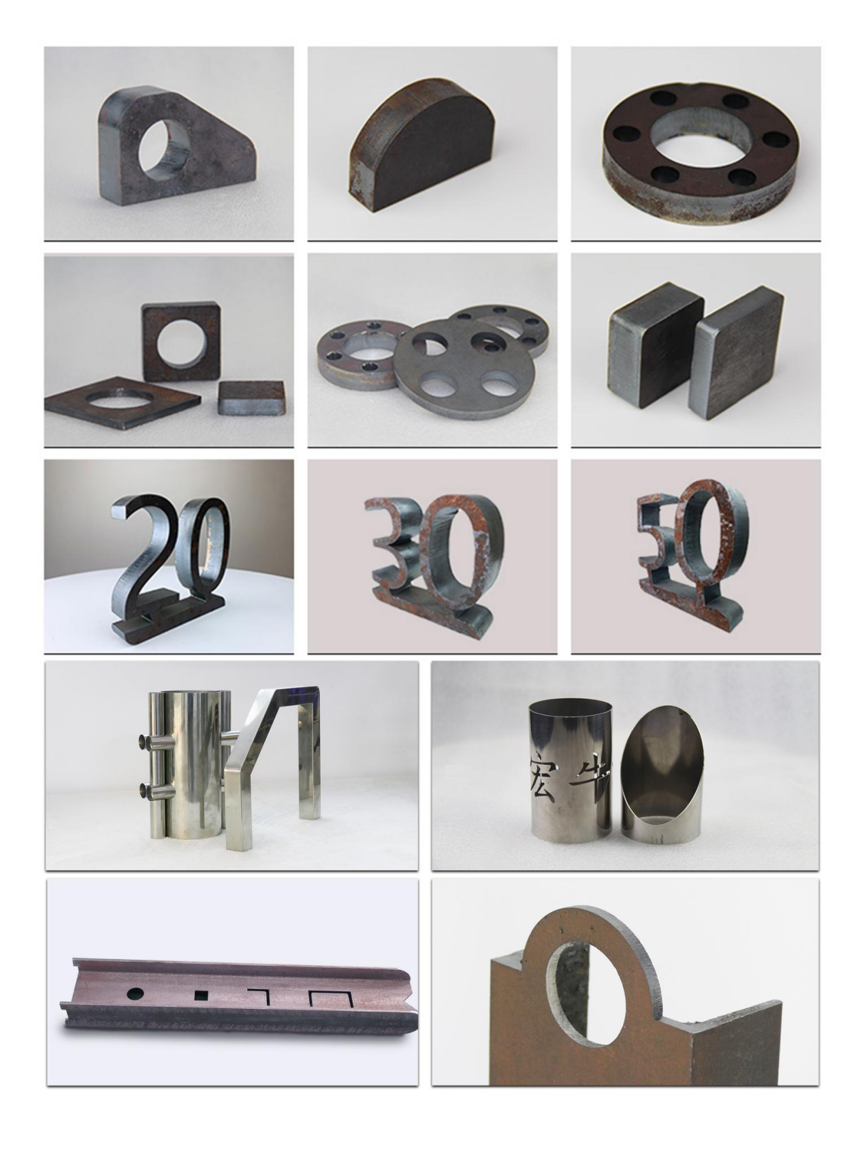
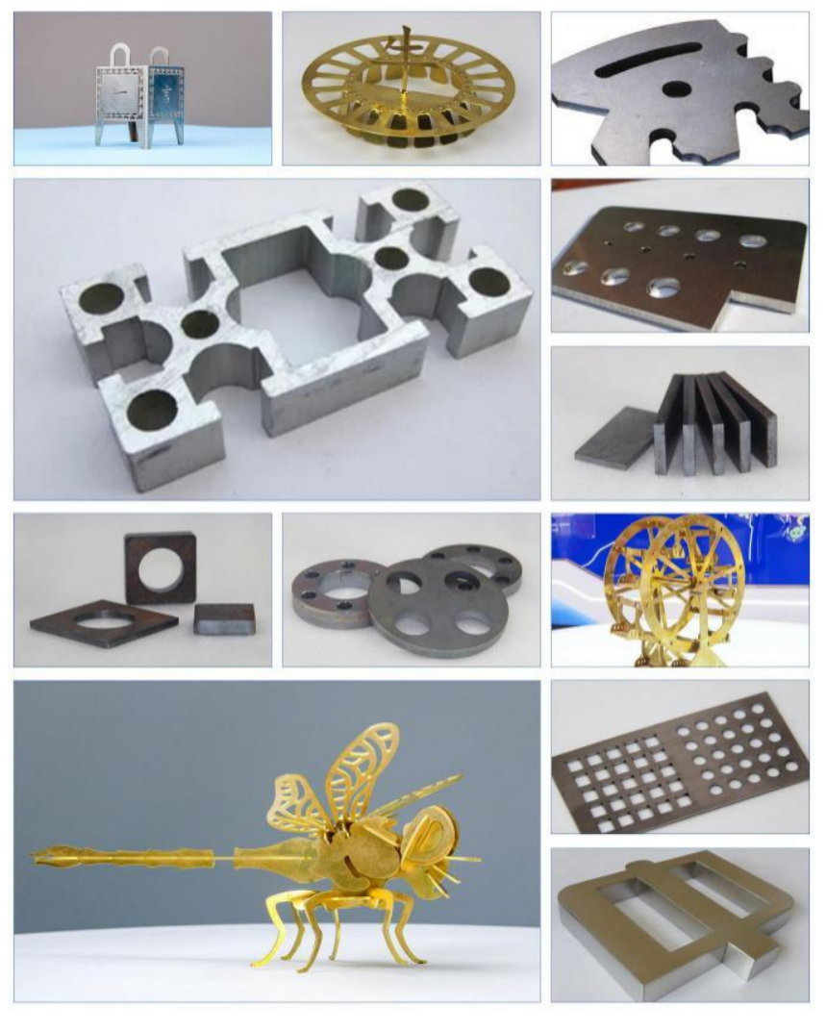
Cutting Parameter12kw
激光器型号/fiber laser model |  | RFL-12000(100u) |  | 切割头光学配比/Cutting head optical ratio |  | 准直/Collimating lensF100/聚焦/focus lens F150
材料/material | 厚度/thickness [mm] | 速度/speed [m/min] | 功率/power [W] | 气体/assist gas | 气压/pressure [bar] | 喷嘴/nozzle type [mm] | 焦点位置/focus site [mm] | 切割高度/laser head height[mm]
碳钢/carbon steel | 1 | 50-60 | 12000 | N₂/Air | 12 | 1.5S | 0 | 1
碳钢/carbon steel | 2 | 35-40 | 12000 | N₂/Air | 12 | 2.0S | 0 | 0.5
碳钢/carbon steel | 3 | 28-33 | 12000 | N₂/Air | 13 | 2.0S | 0 | 0.5
碳钢/carbon steel | 4 | 20-24 | 12000 | N₂/Air | 13 | 2.5S | 0 | 0.5
碳钢/carbon steel | 5 | 15-18 | 12000 | N₂/Air | 13 | 2.5S | 0 | 0.5
碳钢/carbon steel | 6 | 10-13 | 12000 | N₂/Air | 13 | 2.5S | 0 | 0.5
碳钢/carbon steel | 8 | 7-10 | 12000 | N₂/Air | 13 | 3.0S | -1.5 | 0.5
碳钢/carbon steel | 10 | 6-6.5 | 12000 | N₂/Air | 13 | 4.0S | -3 | 0.5
碳钢/carbon steel | 10 | 2-2.3 | 6000 | O₂正焦 | 0.6 | 1.2E | +6 | 0.8
碳钢/carbon steel | 12 | 1.8-2 | 7500 | O₂正焦 | 0.6 | 1.2E | +7 | 0.8
碳钢/carbon steel | 14 | 1.6-1.8 | 8500 | O₂正焦 | 0.6 | 1.4E | +7 | 0.8
碳钢/carbon steel | 16 | 1.5-1.6 | 9500 | O₂正焦 | 0.6 | 1.4E | +8 | 0.8
碳钢/carbon steel | 20 | 1.3-1.4 | 12000 | O₂正焦 | 0.6 | 1.6E | +8 | 0.8
碳钢/carbon steel | 22 | 0.9-1 | 12000 | O₂正焦 | 0.7 | 1.8E | +9 | 0.8
碳钢/carbon steel | 22 | 1-1.2 | 12000 | O₂正焦 | 0.7 | 1.4SP | +11 | 0.5
碳钢/carbon steel | 25 | 0.7-0.9 | 12000 | O₂正焦 | 0.7 | 1.8E | +11 | 0.8
碳钢/carbon steel | 25 | 0.8-1 | 12000 | O₂正焦 | 0.7 | 1.5SP | +12 | 0.5
碳钢/carbon steel | 30 | 0.4-0.5 | 12000 | O₂正焦 | 1.3 | 1.8E | +11 | 1.2
碳钢/carbon steel | 30 | 0.7-0.8 | 12000 | O₂正焦 | 0.8 | 1.5SP | +12 | 0.5
碳钢/carbon steel | 40 | 0.25-0.3 | 12000 | O₂正焦 | 1.5 | 1.8E | +11.5 | 1.2
碳钢/carbon steel | 12 | 3-3.5 | 12000 | O₂负焦 | 1 | 1.6SP | -10 | 1.5
碳钢/carbon steel | 14 | 3-3.2 | 12000 | O₂负焦 | 1 | 1.6SP | -10 | 1.5
碳钢/carbon steel | 16 | 2.8-3 | 12000 | O₂负焦 | 1 | 1.6SP | -12 | 1.5
碳钢/carbon steel | 20 | 2-2.3 | 12000 | O₂负焦 | 1.2 | 1.6SP | -12 | 1.5
碳钢/carbon steel | 25 | 1.1-1.3 | 12000 | O₂负焦 | 1.3 | 1.8SP | -14 | 1.5
碳钢/carbon steel | 30 | 0.9-1 | 12000 | O₂负焦 | 1.4 | 1.8SP | -14 | 1.5
不锈钢/stainless steel | 1 | 50-60 | 12000 | N₂ | 10 | 2.0S | 0 | 1
不锈钢/stainless steel | 2 | 40-45 | 12000 | N₂ | 12 | 2.0S | 0 | 0.5
不锈钢/stainless steel | 3 | 30-35 | 12000 | N₂ | 13 | 2.0S | 0 | 0.5
不锈钢/stainless steel | 4 | 22-26 | 12000 | N₂ | 12 | 2.0S | 0 | 0.5
不锈钢/stainless steel | 5 | 15-18 | 12000 | N₂ | 15 | 2.5S | 0 | 0.5
不锈钢/stainless steel | 6 | 13-15 | 12000 | N₂ | 8 | 3.5B | 0 | 0.5
不锈钢/stainless steel | 8 | 8-10 | 12000 | N₂ | 7 | 5.0B | 0 | 0.5
不锈钢/stainless steel | 10 | 6.5-7.5 | 12000 | N₂ | 5 | 5.0B | -1 | 0.5
不锈钢/stainless steel | 12 | 5-5.5 | 12000 | N₂ | 6 | 6.0B | -4 | 0.5
不锈钢/stainless steel | 14 | 3-3.5 | 12000 | N₂ | 6 | 7.0B | -6 | 0.3
不锈钢/stainless steel | 16 | 2-2.3 | 12000 | N₂ | 6 | 7.0B | -8 | 0.3
不锈钢/stainless steel | 18 | 1.3-1.5 | 12000 | N₂ | 6 | 7.0B | -9 | 0.5
不锈钢/stainless steel | 20 | 1.2-1.4 | 12000 | N₂ | 6 | 7.0B | -11 | 0.3
不锈钢/stainless steel | 25 | 0.7-0.9 | 12000 | N₂ | 6 | 7.0B | -13 | 0.3
不锈钢/stainless steel | 30 | 0.25-0.3 | 12000 | N₂ | 10 | 7.0B | +7 | 0.3
不锈钢/stainless steel | 40 | 0.15-0.2 | 12000 | N₂ | 15 | 7.0B | +8 | 0.3
不锈钢/stainless steel | 1 | 50-60 | 12000 | Air | 10 | 2.0S | 0 | 1
不锈钢/stainless steel | 2 | 40-45 | 12000 | Air | 10 | 2.5S | 0 | 0.5
不锈钢/stainless steel | 3 | 30-35 | 12000 | Air | 10 | 2.5S | 0 | 0.5
不锈钢/stainless steel | 4 | 22-28 | 12000 | Air | 10 | 3.5B | 0 | 0.5
不锈钢/stainless steel | 5 | 16-19 | 12000 | Air | 10 | 3.5B | 0 | 0.5
不锈钢/stainless steel | 6 | 14-17 | 12000 | Air | 10 | 3.5B | 0 | 0.5
不锈钢/stainless steel | 8 | 9-11 | 12000 | Air | 10 | 3.5B | 0 | 0.5
不锈钢/stainless steel | 10 | 7-8 | 12000 | Air | 10 | 3.5B | -1 | 0.5
不锈钢/stainless steel | 12 | 5.5-6 | 12000 | Air | 10 | 5.0B | -4 | 0.5
不锈钢/stainless steel | 14 | 3.5-4 | 12000 | Air | 10 | 5.0B | -6 | 0.5
不锈钢/stainless steel | 16 | 2.2-2.4 | 12000 | Air | 10 | 5.0B | -8 | 0.5
不锈钢/stainless steel | 18 | 1.3-1.6 | 12000 | Air | 10 | 5.0B | -9 | 0.5
不锈钢/stainless steel | 20 | 1.2-1.5 | 12000 | Air | 10 | 5.0B | -11 | 0.3
不锈钢/stainless steel | 25 | 0.7-1 | 12000 | Air | 10 | 5.0B | -13 | 0.3
不锈钢/stainless steel | 30 | 0.3-0.6 | 12000 | Air | 10 | 5.0B | -14 | 0.3
铝合金 | 1 | 45-50 | 12000 | N₂ | 12 | 2.0S | 0 | 0.8
铝合金 | 2 | 30-35 | 12000 | N₂ | 12 | 2.0S | -1 | 0.5
铝合金 | 3 | 20-25 | 12000 | N₂ | 12 | 2.0S | -1 | 0.5
铝合金 | 4 | 18-20 | 12000 | N₂ | 12 | 2.0S | -2 | 0.5
铝合金 | 5 | 14-16 | 12000 | N₂ | 14 | 2.5S | -3 | 0.5
铝合金 | 6 | 10-12 | 12000 | N₂ | 14 | 2.5S | -3 | 0.5
铝合金 | 8 | 6-8 | 12000 | N₂ | 14 | 2.5S | -4 | 0.5
铝合金 | 10 | 4-6 | 12000 | N₂ | 14 | 5.0B | -5 | 0.5
铝合金 | 12 | 2-3 | 12000 | N₂ | 16 | 5.0B | -5 | 0.5
铝合金 | 14 | 1.5-2.5 | 12000 | N₂ | 16 | 5.0B | -5 | 0.5
铝合金 | 16 | 1.3-2 | 12000 | N₂ | 16 | 5.0B | -5 | 0.5
铝合金 | 18 | 1-1.6 | 12000 | N₂ | 16 | 5.0B | -5 | 0.5
铝合金 | 20 | 0.8-1.2 | 12000 | N₂ | 16 | 7.0B | -5 | 0.3
铝合金 | 25 | 0.5-0.7 | 12000 | N₂ | 16 | 7.0B | -5 | 0.3
铝合金 | 30 | 0.25-0.3 | 12000 | N₂ | 18 | 7.0B | +7 | 0.3
铝合金 | 40 | 0.15-0.2 | 12000 | N₂ | 18 | 7.0B | +8 | 0.3
黄铜 | 1 | 35-45 | 12000 | N₂ | 12 | 2.0S | 0 | 1
黄铜 | 2 | 30-35 | 12000 | N₂ | 12 | 2.0S | -1 | 0.5
黄铜 | 3 | 18-22 | 12000 | N₂ | 12 | 2.0S | -1 | 0.5
黄铜 | 4 | 15-18 | 12000 | N₂ | 12 | 2.0S | -2 | 0.5
黄铜 | 5 | 12-15 | 12000 | N₂ | 14 | 2.5S | -3 | 0.5
黄铜 | 6 | 8-10 | 12000 | N₂ | 14 | 2.5S | -3 | 0.5
黄铜 | 8 | 5-7 | 12000 | N₂ | 14 | 2.5S | -4 | 0.5
黄铜 | 10 | 4-5 | 12000 | N₂ | 14 | 5.0B | -5 | 0.5
黄铜 | 12 | 1.8-2 | 12000 | N₂ | 14 | 5.0B | -5 | 0.5
黄铜 | 14 | 1.2-1.4 | 12000 | N₂ | 16 | 5.0B | -8 | 0.5
黄铜 | 16 | 0.8-1 | 12000 | N₂ | 16 | 5.0B | -11 | 0.3
紫铜 | 1 | 25-30 | 12000 | O₂ | 5 | 2.0S | -0.5 | 1
紫铜 | 2 | 20-25 | 12000 | O₂ | 5 | 2.0S | -1 | 0.5
紫铜 | 3 | 16-18 | 12000 | O₂ | 6 | 2.0S | -2 | 0.5
紫铜 | 4 | 10-12 | 12000 | O₂ | 8 | 2.0S | -3 | 0.5
紫铜 | 5 | 6-8 | 12000 | O₂ | 8 | 2.5S | -4.5 | 0.5
紫铜 | 6 | 4-5 | 12000 | O₂ | 8 | 2.5S | -5 | 0.5
紫铜 | 8 | 2-2.5 | 12000 | O₂ | 10 | 3.0S | -6 | 0.5
紫铜 | 10 | 1-1.2 | 12000 | O₂ | 12 | 4.0S | -8 | 0.5
备注：表中红标参数为打样参数，在实际加工中受各类因素影响较大，仅适合小批量生产，不推荐大批量生产加工，建议使用更高功率激光器。
Note: The red marked parameters in the table are proofing parameters, which are greatly affected by various factors in actual processing. They are only suitable for small batch production. Mass production and processing are not recommended. It is recommended to use higher power lasers.

Using cost 12kw
12000W 光纤机使用成本分析 12000W Fiber laser using cost
辅助气体 Assisted gas 能耗 Consumption |  | 可选方案一：  空气切割（用空压机组切割不锈钢板）  ChooseⅠ:using air compressor Group as air supply to cutting Stainless steel | 可选方案二：  氧气切割（用 O2 切割不锈钢）  ChooseⅡ:using O2  Cutting Stainless steel | 可选方案三：  氮气切割（用 N2 切割不锈钢）  ChooseⅢ:using N2  Cutting Stainless steel
电 力 消 耗Power Consumption | 激光器  Laser module | 36kw | 36kw | 36kw
电 力 消 耗Power Consumption | 冷水机组  Water Chiller Group | 14kw | 14kw | 14kw
电 力 消 耗Power Consumption | 机床主机  Host Machine | 16kw | 16kw | 16kw
电 力 消 耗Power Consumption | 除尘设备  Dust Exhausting Equipment | 5kw | 5kw | 5kw
易损件 Quick-wear Part |  | 2.5 RMB/h | 2.5 RMB/h | 2.5 RMB/h
气体消耗 Gas Consumption |  | 15kw | 约（About）  25 RMB/h | 约（About）100 RMB/h
总电力功率 Total Power |  | 86 kw | 71 kw | 71 kw
平均功率（取 60％切割效率） Average Power Consunption  (Take 60％Cutting Efficiency) |  | 86x60％=51.6 kw | 71x60％=42.6kw | 71x60％=42.6kw
总运行成本 All Cost  (按 1RMB/kwh) |  | 51.6+2.5=54.1 RMB/h | 42.6+2.5+25=70.1 RMB/h | 42.6+2.5+100=145.1 RMB/h

Ⅷ、After Sale Service
Technology support
We will send our engineer to the customers’ place to help install,test the machine,and to train the customers’ technicians ,our engineer will stay at customers’ place for 5-7 days,customers should pay the round-trip air tickets/hotels/food fees/visa fee for our engineer. Training fee is 100 USD each day.

Exhibition support
If our agents need technical support at their show,our engineer will go to your show and work together,customers should pay the
round-trip air tickets/hotels/food fees/ visa fee/ technical support fee 100 USD each day.

24hours online service
The customers’ technicians can keep in touch with our engineer at any time,through wechat/whatsapp/mobile phone or email,our engineer will help to solve your problems as soon as possible.

THANK YOU FOR YOUR ATTENTION

JINAN HONGNIU MACHINERY EQUIPMENT CO.,LTD
Any question contact M.s Sophia Liu
Email: sales06@hongniulaser.com
Wechat:lasermachine2025

